
1-Hitter Programmers

MEMORANDUM

To: Paul Iverson (piverson@instructor.yc.edu)
From: 1-Hitter Programmers
Brian Cullinan
Davis Zanot
Steven Lambright
Subject: Design Specification Guidelines
Date: 2/15/2010

Table of Contents
Introduction 1
Architecture Overview 2
Class Diagram 3
Detailed Module Descriptions 4
Graphical Baseball Card Reports 4
Streamlined Baseball Card Entry Page 4
AZMLA Directory 5
Baseball Player Catalog 7
Implementation Plan 8

Introduction
The Client would like a way to sell donated memorabilia online in order to raise funds for the AZMLA. Team 1-Hitter Programmers will be setting up and configuring a Drupal website using Ubercart to manage the products. We will also be providing a set of plug-in tools for Ubercart that allow the client to input products in the most efficient way possible. Other requirements include:

- The ability for Google to list the products
- Converting the old website content to the new Drupal system
- And designing a new flashy template

The Drupal system will provide the client with a stable basic website, which sometime in the future will be able to update with minimal training. The Ubercart system is a fully featured shopping cart. This system will handle the checkout process and e-mailing orders to the client. The tools will provide and easy access way to update the product listings, including AJAX and auto-fill fields. The old site content will be ported over to the new Drupal system. This will unify the design across all information.

Architechure Overview

Drupal System
Drupal provides a rich programming API that we will take advantage of in this project. First, a base template system will be selected; this will be the starting point for all future layout and design of the site and its content. Using the Drupal API, we will modify modules such as the pre-built statistics page to provide the client with all the needed information. The Ubercart system will also be installed on top of the Drupal API. Finally, we will be creating tools that provide the client with auto-fill functionality. This will make it easy for the client to add baseball cards to the store.

Ubercart
Ubercart is a fully functional shopping cart system that uses the Drupal API. This will be configured to send the client e-mails, register product listings with Google, and accept payments from users. Our tools will use the Ubercart system to insert baseball cards quickly and efficiently.

Graphical Baseball Card Reports
Provides information on sales and site statistics. This module will be a Drupal extension that is talored for our clients use.

Streamlined Baseball Card Entry Page
Since the client has over 100 thousand cards to enter in to this system, it is important that the client can do this quickly and efficiently. This module will streamline this process, and make it simple for the client to add products to the store.

AZMLA Directory
This functionality will be created to display a list of people associated with the AZMLA. This will be an extension of the user profile, and will show up as a full list of information about each person.

Baseball Player Catalog
This module will extend the funtionality of the Ubercart catalog. Adding the ability to select Baseball player criteria to sort and display the products.
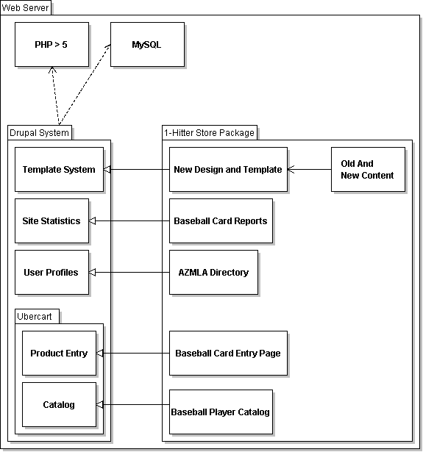

Module: Graphical Baseball Card Reports

Overview
The idea of this module is to provide graphical feedback on how well sports memorabilia is selling by category. For example, one could graphically look at how baseball cards are selling based on the cards' year. This module will consist of a set of hooks into Drupal, a module help file, some CSS, a module install file and an info file which describes the proper versions of dependencies. The code in this module will be all PHP5.
The graphical display of this module will be in the administration area. To access these reports, on the front page click administer and then on the left hand side click reports. Then the user will be given a choice of reports, including but not limited to the original Drupal reports (sales over time, sales over time by category, textual) and the new module's reports (graph of baseball card sales by year, by player, and by team).

Implementation Details
The “.info” file will list dependencies for this module. There are no methods in this file, only variable declarations. These declarations will be interpreted by Drupal to properly describe the module briefly, name it, verify the dependency versions are correct and date the module.
The “.install” file will describe how to install and uninstall this module. It will contain two functions: one for installation and one for removal, both of which contain database query calls.
The “.css” file will describe formatting (positioning) for the graphs.
The “.module” and “.inc” files will implement the module. The “.inc” file will set up parameters such as graph size, where to draw major/minor axis lines, and similar settings. The “.module” file will implement the graphs. The implementation of both of these files will be a set of functions, many hook functions into Drupal, that return necessary data. These functions will be to the effect of “_uc_gbcr_get_sales_graph($report_id, $user_id, $x_axis_category).” The notation “_uc_” stands for Ubercart, “gbcr” is short for the module name, and the rest of the function name describes its purpose.

Module: Streamlined Baseball Card Entry Page

Overview
The idea of this module is to provide an optimized item entry page for baseball cards. Preserving information such as player, year, team between baseball card additions is essential. With 100,000 cards to add to the database, we must make this process absolutely as quick and painless as possible.
The graphical display of this module will be in the administration area. To access this entry method, on the front page click administer and there will be a link on the left hand side. Then the user will be at the streamlined baseball card entry page.

Implementation Details
The “.info” file will list dependencies for this module. There are no methods in this file, only variable declarations. These declarations will be interpreted by Drupal to properly describe the module briefly, name it, verify the dependency versions are correct and date the module.
The “.install” file will describe how to install and uninstall this module. It will contain two functions: one for installation and one for removal, both of which contain database query calls.
The “.css” file will describe formatting (positioning) for basic input elements.
The “.module” and “.inc” files will implement the module. The “.inc” file will set up display parameters. The “.module” file will implement the form. The implementation of both of these files will be a set of functions, many hook functions into Drupal, that return necessary data. These functions will be to the effect of “_uc_sbcep_product_form(&$node).” The notation “_uc_” stands for Ubercart, “sbcep” is short for the module name, and the rest of the function name describes its purpose.

Module: AZMLA Directory

Overview
The idea of this module is to provide a list of people associated with the AZMLA with profiles for each. This replaces the old directory, pictured below.
This module should be a beautified version of the existing directory. We're aiming for something more like KJACK's Managers page, pictured below.

This module should provide descriptions of everyone in the directory, optionally a picture, and contact information. This module will also include a page for instructors to also replace the old instruction page, which has nearly identical content.

Implementation Details
The “.info” file will list dependencies for this module. There are no methods in this file, only variable declarations. These declarations will be interpreted by Drupal to properly describe the module briefly, name it, verify the dependency versions are correct and date the module.
The “.install” file will describe how to install and uninstall this module. It will contain two functions: one for installation and one for removal, both of which contain database query calls.
The “.css” file will describe formatting (positioning) for basic input elements.
The “.module” and “.inc” files will implement the module. The “.inc” file will set up display parameters. The “.module” file will implement the directory page. The implementation of both of these files will be a set of functions, many hook functions into Drupal, that return necessary data. These functions will be to the effect of “_uc_directory_get_entry(&$node).” The notation “_uc_” stands for Ubercart, “directory” is the module name, and the rest of the function name describes its purpose.

Module: Baseball Player Catalog

Overview
The idea of this module is to teach Ubercart about which teams existed in which years and which players were on which teams. When a user selects a year to search for baseball cards the available teams will be listed. This module will be a dependency for the baseball card entry page and graphical baseball card reports modules. This module should be useful for improving the perceived intelligence of the website by users and to simplify searching for products, adding new products and displaying graphical reports.

Implementation Details
The “.info” file will list dependencies for this module. There are no methods in this file, only variable declarations. These declarations will be interpreted by Drupal to properly describe the module briefly, name it, verify the dependency versions are correct and date the module.
The “.install” file will describe how to install and uninstall this module. It will contain two functions: one for installation and one for removal, both of which contain database query calls.
The “.css” file will describe formatting (positioning) for basic display elements.
The “.module” and “.inc” files will implement the module. The “.inc” file will set up general parameters. The “.module” file will implement the module. The implementation of both of these files will be a set of functions, many hook functions into Drupal, that return necessary data. These functions will be to the effect of “_uc_catalog_get_teams($year).” The notation “_uc_” stands for Ubercart, “catalog” is short for the module name, and the rest of the function name describes its purpose.

Implementation Plan

